Using the manual GUI

Gustav Pettersson January 2018

# Ensure:

You have read and understood the “Introduction to the SPS” document and that you have your SPSs ready for use. First, we need to set up the software.

# Software setup:

Open “runManual_SPS_GUI” in Matlab. There are three fields that must be filled in correctly. For each SPS you will use you need to know the following:

1. What is the unique hardware ID of this SPS?
2. What power input and fan is this SPS using? Only these answers are acceptable:
   1. NO: No fan and 12V input. Limited to 8V 1.1A.
   2. HC: 12V fan and 12V input. Limited to 8V 2.1A.
   3. HV: 24V fan and 24V input. Limited to 21V 1.1A.
3. What input on the satellite will this SPS be connected to?

Note that the SPS measures voltage and provides current. It is safe to use a higher voltage rating on the SPS than the input on the satellite in normal operation. BUT if there is a problem the SPS may short and send the voltage through! **Use a fuse and Zener diode to build a simple and reliable overvoltage and overcurrent protection (see e.g.** [**here**](http://www.learningaboutelectronics.com/Articles/Overvoltage-protection-circuit.php)**).**

List the hardware IDs you are using:

SPS_HW_IDS = [7 5 6];

Then, keeping order intact, list the types:

SPS_TYPES = {'NO' 'HC' 'HV'};

Then, keeping order intact, list the input you will simulate. List either ‘MPPT x’ or ‘PANEL x’ where x is replaced with a number.

SPS_LABELS = {'MPPT 1' 'MPPT 2' 'MPPT 3'};

Make sure the SPSs are not connected to the satellite and run the script. All being well, you should get windows looking like these opening: (one for each SPS)

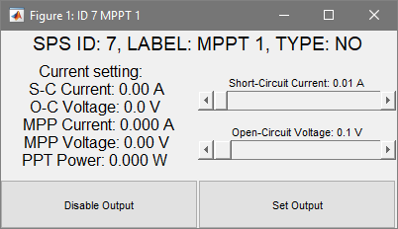

On the top row, the parameters for this SPS are shown. Ensure that the hardware ID, label, and type match what you expect! Now click “Disable Ouput” and see that the LED on the Teensy becomes brighter momentarily (this is when the Teensy is receiving data), so that you also have the correct SPS connected to the expected window. Repeat this for all SPSs. If all is well you may proceed to connecting the hardware to you satellite.

# Hardware Setup

Start your satellite power system and stream the housekeeping data to a computer to keep an eye on its status. With the SPS outputs all disabled, connect them to the satellite power system in the desired ports. Always be ready to unplug the power if anything seems strange! Now, for one SPS at a time, set the short-circuit current and open-circuit voltage to something reasonable (e.g. 0.1A 6V) and press “Set Output”. The GUI should look something like this:

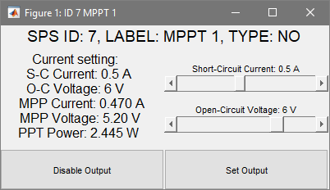

On the left-hand side, the current settings are listed. Look in the housekeeping data to see that the correct input (in this case MPPT 1) has been powered. Compare the input voltage and current on the SPS display and the housekeeping data, they should match! Disable this output and then repeat for all other connected SPSs.

Congratulations! Your satellite is now powered by the SPS and you can begin testing. The first thing to note is the MPP current and voltage. The housekeeping data should report something similar, otherwise the MPPT is not doing its job! Now play around with the voltage and current that you set to the power system on the various SPSs, and click “Set Ouput” to send your settings.

# Shutting down

When you are finished, click “Disable Output” on each SPS. Read the display on the SPS, it should read (almost) 0A of current. Disconnect it from the satellite power system before unplugging the power to the SPS. Close the Matlab windows (If you have unplugged the SPS power, you will get an error message in Matlab, this is expected).